Emile assignment:

- Interdiction Page:

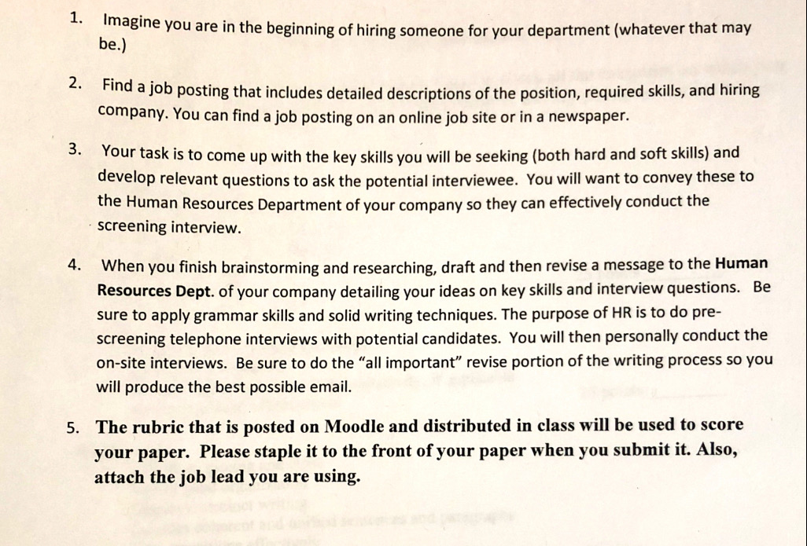

- Picture is the Job Leads I chose:

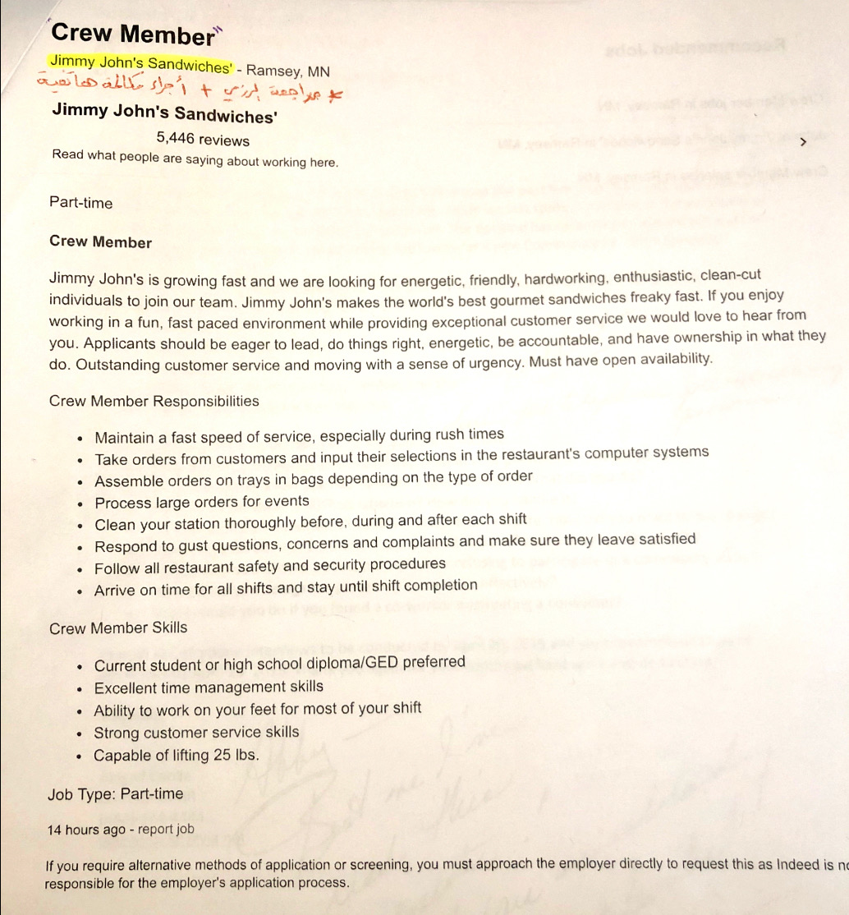

- The excellent example of the Emil should look like: